West Kentish Town Redevelopment Team
104a Queens Crescent
NW5 4DU
Phone: 020 7974 1040
camden.gov.uk

Date:  Our reference:  Email: | 18 July 2023  WKTE/playspacesurvey  wkt@camden.gov.uk

Dear young resident,

Play spaces for Young People

As you may know, Camden Council is rebuilding your estate to give all residents brand new modern homes. This redevelopment will also include improvements to the neighbourhood, new play spaces and better landscaping, which you have told us are so important for residents’ wellbeing.

The first new homes will be built on the MUGA (Basketball Court). The West Kentish Town Estate Redevelopment Team are reaching out to young residents to talk about permanent and temporary play spaces, as we recognise that you will be impacted by the removal of the ball court. As the users of these spaces, we want to hear your thoughts on the facilities we are creating.

There will also be opportunities to be involved in designing the artwork for our hoardings with artists, participate in sports activities at the MUGA this summer and other activities.

Along with this letter, we have attached a survey asking you about your views. If you are a parent, you can help your child complete this survey. We look forward to hearing from you as your involvement will play an important role in making the estate safe and enjoyable during the building programme, as well as shaping the future vision for the redevelopment of the estate and the long-term success of the neighbourhood that you will inherit.

If you have any questions or would like to speak to a member of the team about this, please contact us at: wkt@camden.gov.uk or 0207 974 1040.

Yours Faithfully,

Hodan Mahamoud
Consultation and Engagement Officer
Development

Name:

…………………………………………………………………………………………………………

Address:

…………………………………………………………………………………………………………

………………………………………………………………………………………………………..

Age: □ 0 – 10 □ 10 – 16 □ 16 – 25

How much do you use the ball court in the estate? If you go somewhere else to play, where do you go and what do you use there?

As part of the proposals, we would like to create play facilities for young people to use. Examples of the equipment which could be provided are:

- Basketball Net
- Table Tennis
- Temporary/Outside Gym facilities
- Some seating areas
- Football area
- Hopscotch area
- Small children’s play area (under 5’s)
Please let us know your thoughts on this or any other ideas you have related to temporary play facilities on the estate:

We would like to create insect boxes for young residents to observe their lifecycle and learn more about insects. What do you think of this?

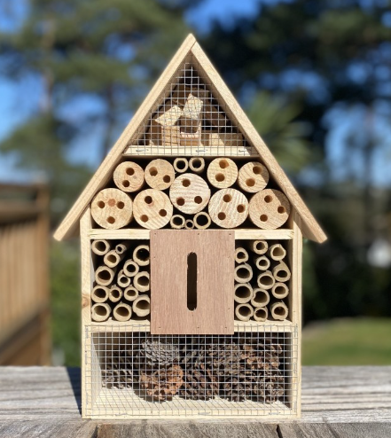

□ I like this idea
□ I don’t like this idea
□ I don’t know
□ Other (please let us know your thoughts in the box below)

We would like to hear your views on the best way to engage with young people about the West Kentish Town Redevelopment project and the type of activities you might be interested in getting involved with.

How can we best engage with young people about the West Kentish Town Redevelopment Project?
- Letters
- Noticeboards
- Social Media
- Other (please put your comments in the box below)

We would like to involve young residents to work with creative artists and design the artwork for our hoardings, would you like to be part of this?

□ Yes
□ No
□ I don’t know

We would like to hear from young people about your views on the redevelopment and what is important to you, your aspirations for your community and environment. Would you be interested in joining a Young People’s Redevelopment Group?

□ Yes
□ No
□ I don’t know

Is there anything you would like to tell us about this consultation or the West Kentish Estate redevelopment project?

Date ………………………………...

Signature (if you are under 18 years old, you will need a signature or consent from a parent/guardian on your behalf)

………………………….………………………………….

Please return the completed form to our office at: 104a Queen’s Crescent, NW5 4DU or send by post in the envelope provided, to the address at the top of this letter.

